DataGrip Installation

DataGrip is a powerful GUI that allows us to query and visualize our remote database. In order to connect to it, we first need to install it.

1. Visit the following link <https://www.jetbrains.com/datagrip/>
2. Use your student account to receive the full non-trial version

DataGrip Setup

Once installed, open DataGrip and follow the instructions below:

1. Select File > Data Sources
2. Select + in the top left
3. Select Postgresql

Since the DB is located on the remote server, we need to first SSH into the server.

1. Select the SSH tab and fill out with the following details:
   1. 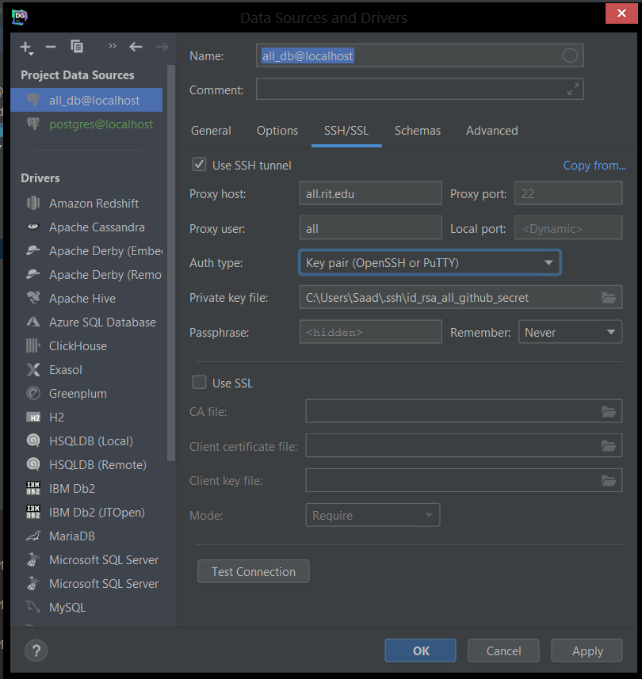
2. For the private key, select the path to the local private key file
   1. If you do not have this, you must create it using ssh-keygen <https://www.ssh.com/ssh/keygen/>
   2. Store the private key locally and upload the public key contents to the all.rit.edu server in the /home/all/.ssh/**authorized_keys** file. Append to bottom of file
3. Test connection to ensure it works properly. There will be a success message.

Next we need to configure general settings.

1. Select the general tab and add the following details:
   1. 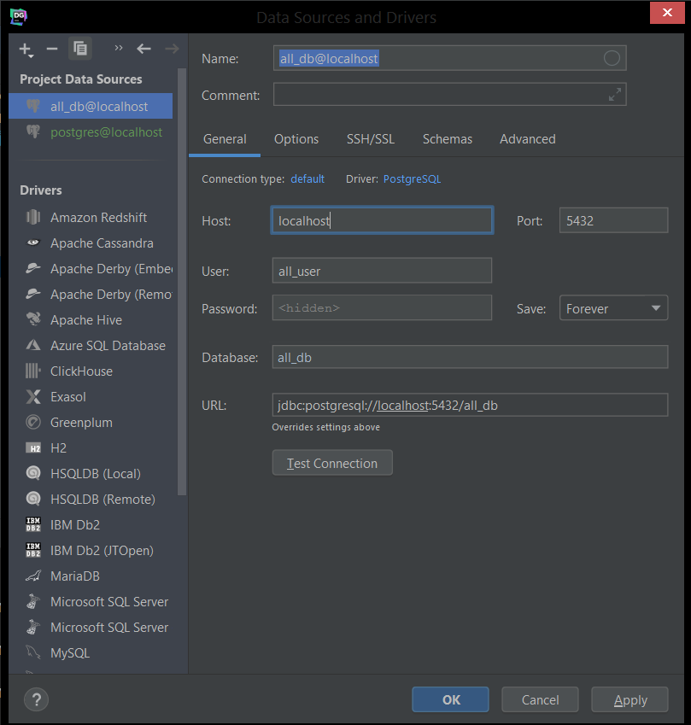
2. Make sure to fill out the password with the DB password found in the .env file under the server folder (can be found on the server if not on local machine ‘/home/all/research/AccessibilityLab1/server/**.env**’)
3. Click test connection and ensure it is successful
4. Click Apply and OK
5. You should see the following
   1. 